# Create an App in Xcode

## ~~Create a new Xcode project~~

~~On the File menu in Xcode, choose New then Project. You will see the following dialog box:~~

~~SAME~~

~~Choose Single View App and click Next. You will see the following dialog:~~

~~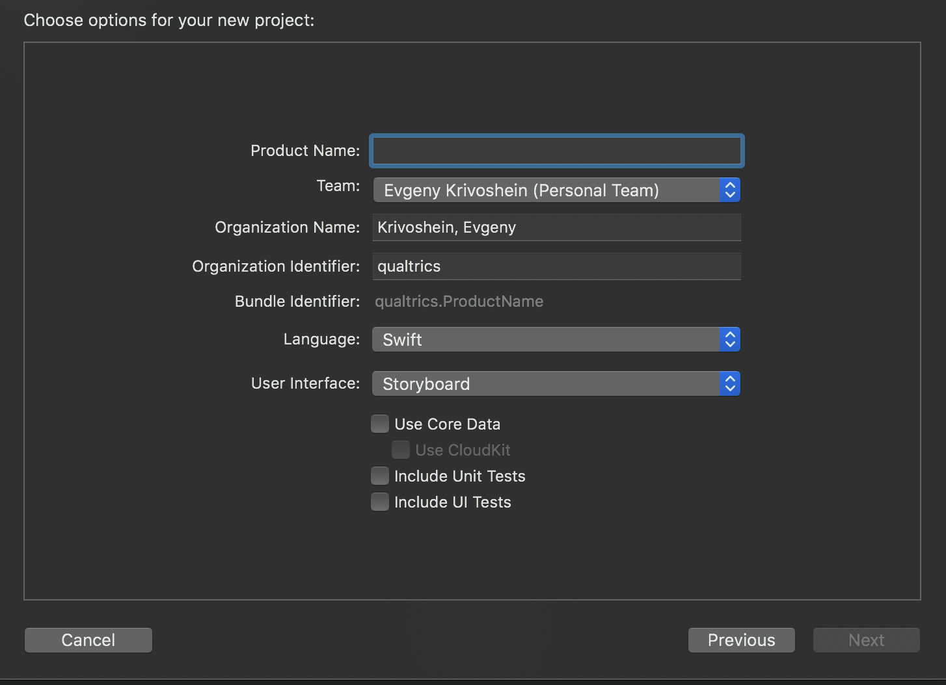~~

~~Name your app and choose a team. Your team is registered with iTunes Connect and your developer account. You can also create a private app if you do not have an Apple Developer account. For more information, see~~ [~~Adding Your Account to Xcode~~](https://developer.apple.com/library/content/documentation/IDEs/Conceptual/AppStoreDistributionTutorial/AddingYourAccounttoXcode/AddingYourAccounttoXcode.html)~~. In “User Interface” field select~~ **~~Storyboard~~**

## Installing the Framework manually

This step is optional. If you would like to avoid installing and using Cocoapods, you can install the framework manually. Select and download the latest framework as a zip file from [iOS Releases](https://api.qualtrics.com/docs/si-ios-releases).

Unzip the file to find a LICENSE file and a Qualtrics.framework folder. Open Xcode and select the project in the navigator pane. From there, select the app under Targets and choose General to view the General settings window.

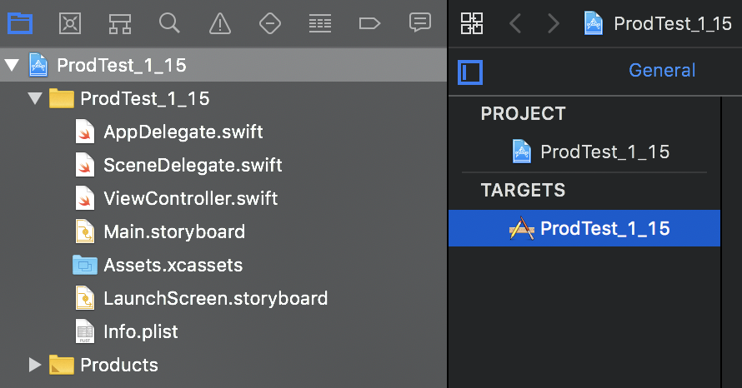

At the bottom of the settings page is a section labeled **Frameworks, Libraries and Embedded Content**. Click the + button in this section.

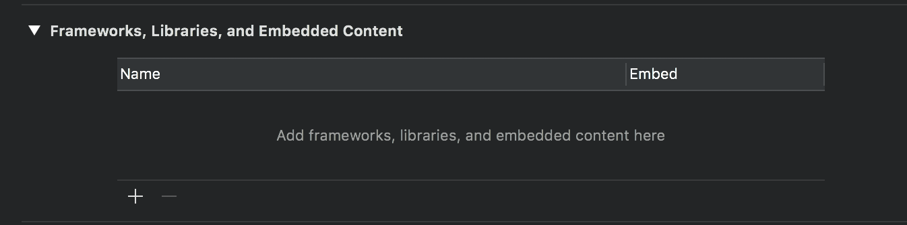

In the dialog that appears (shown below), click on the **Add Other… -> Add Files...** button to display an open file dialog.

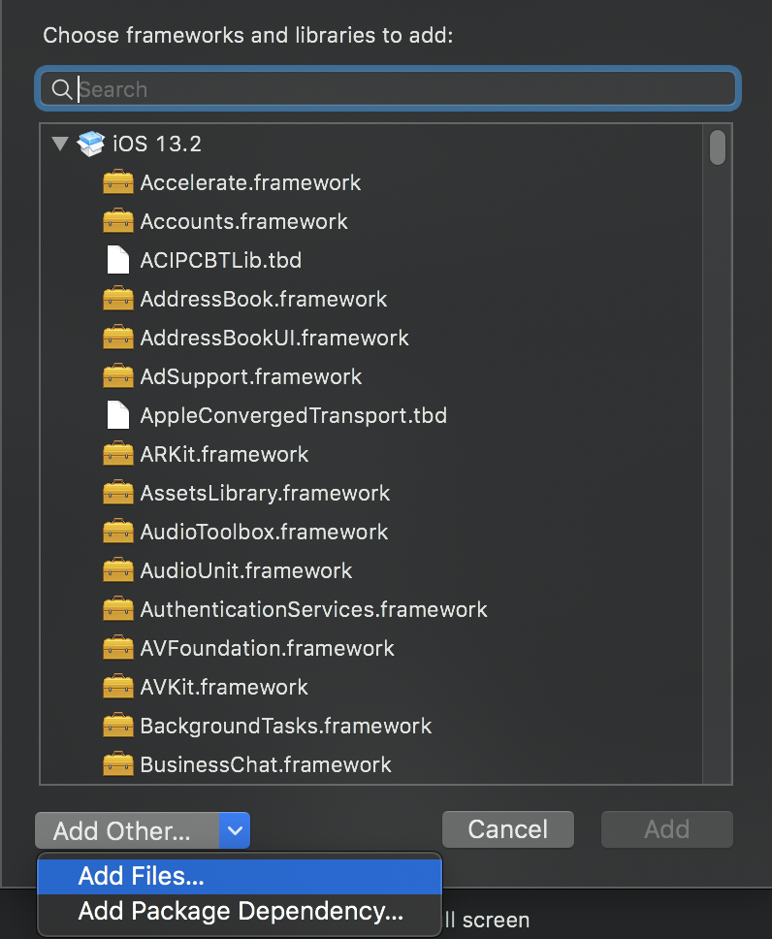

Navigate to the location where the SDK was unzipped (Project root), select the Qualtrics framework, and click on the Open button. In the options dialog that appears, check the Copy items if needed option and click the Finish button. The SDK will appear under the **Frameworks, Libraries and Embedded Content**, as shown below:

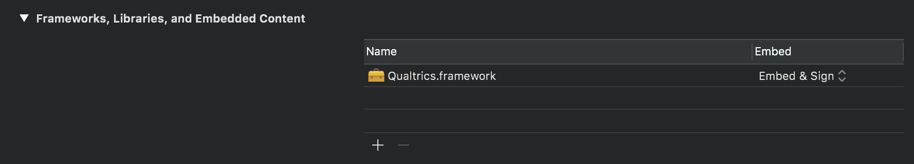

# Add the App Feedback Code

## Set up the App Delegate

Click on AppDelegate.m or AppDelegate.swift (depending on your language) to open the view controller's source file in the editor.

Add the following import to the top of the file depending on the language:

<code>

## Initialize the Qualtrics Singleton

**Objective-C is outdated! (double check with Ryan from implementations)**

Add the following code to the **AppDelegate application method body:**

<code>

Replace BRAND ID, PROJECT ID, and INTERCEPT ID with the intercept ID you obtained earlier.

The code should look like the following:

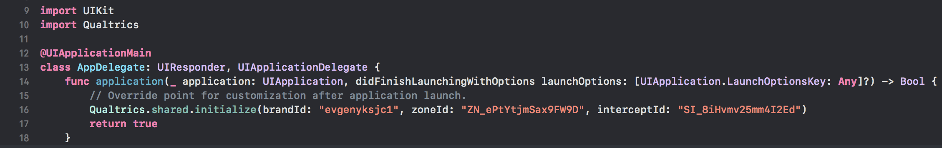

### Add a Button

Now open the file called Main.storyboard. Click Adjust Editor Options in right top corner: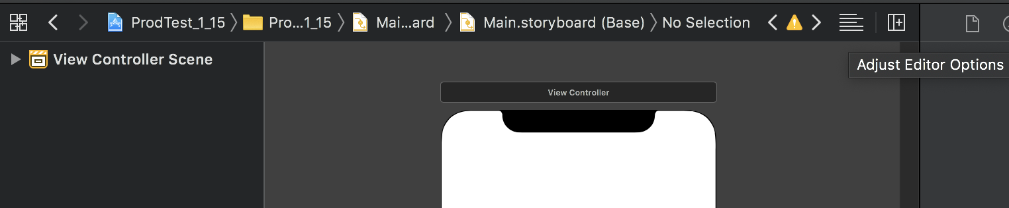

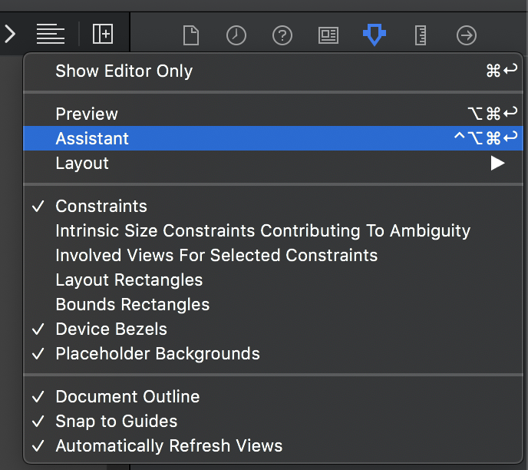

And enable Assistant. Now you can see UI and code side by side:

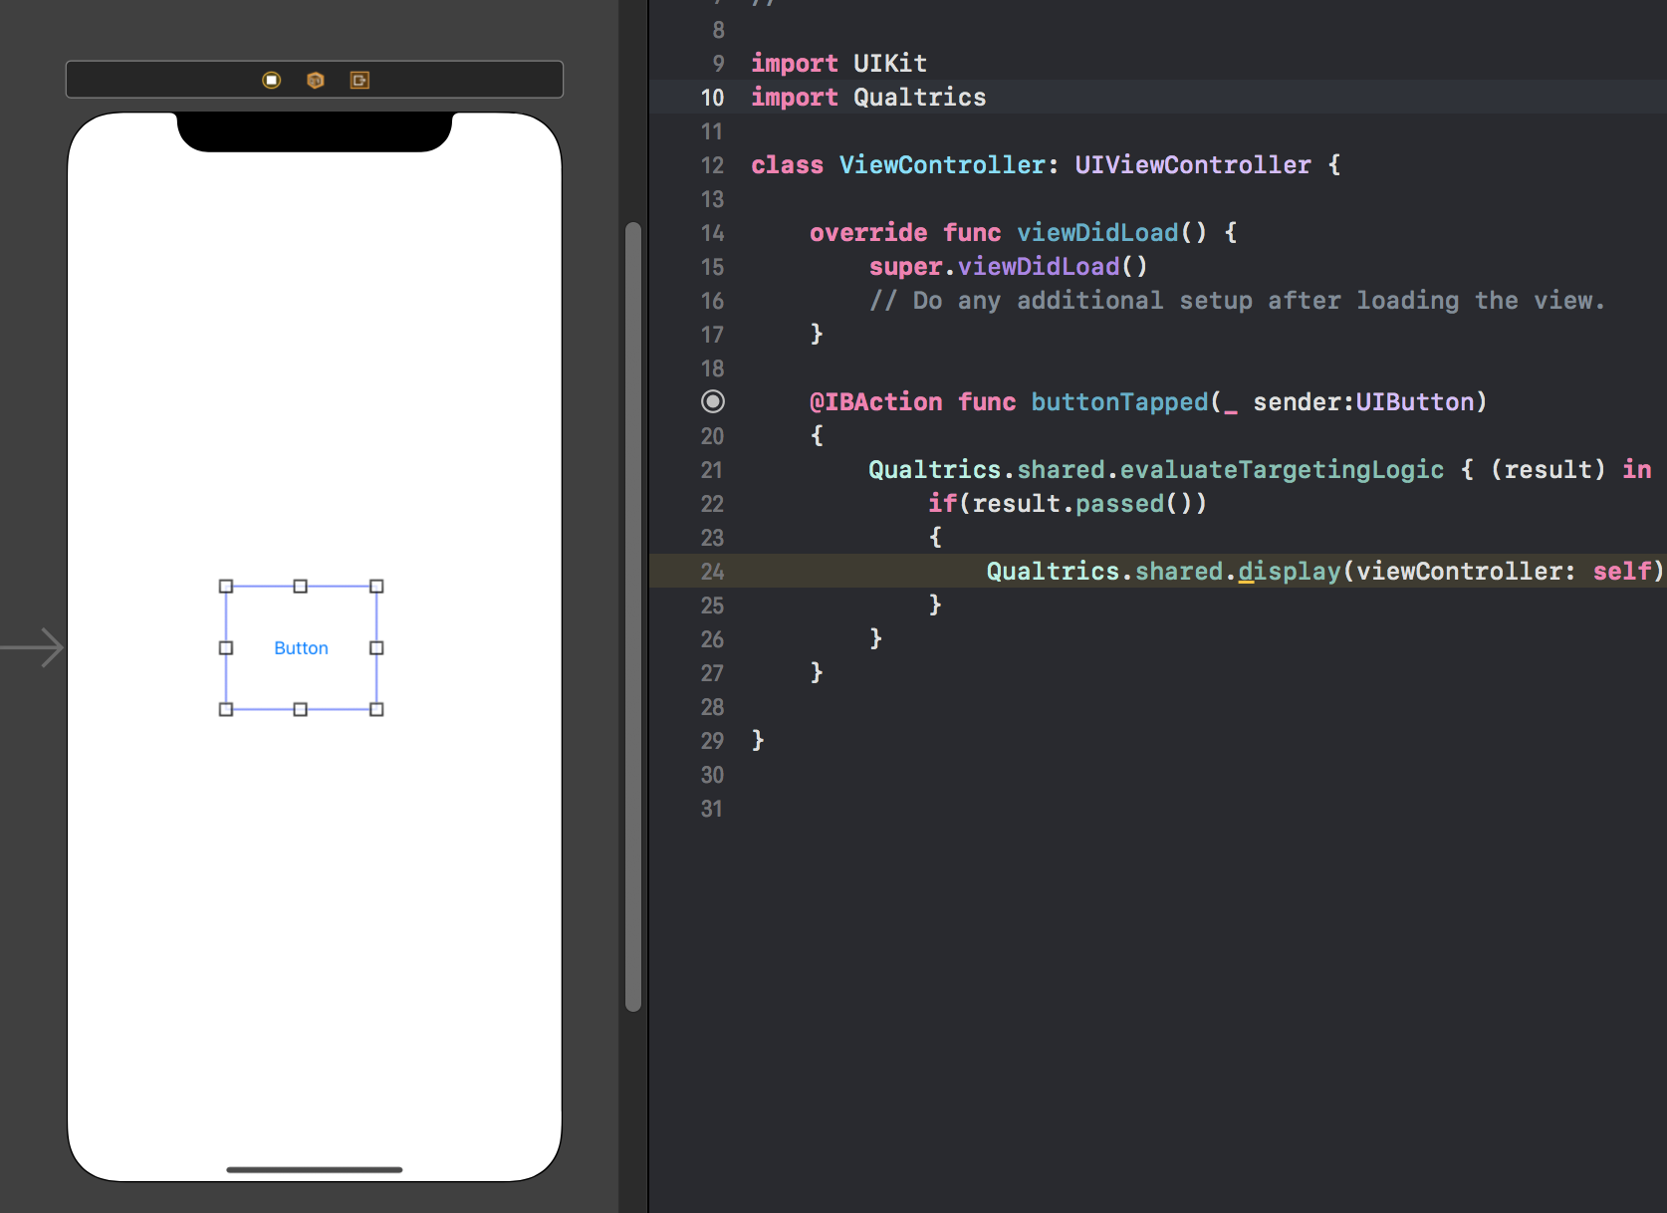

Button to the UI can be added via View->Show Library and double-click on Button control.

While holding down control, drag from the button to the button action code that you just added to the source file. The entire method or function will highlight when you can release the mouse button.

**Run section should be checked**